AGENDA
Wednesday August 23, 2023 6:00 p.m. via Zoom

1. | Welcome and Introductions | Chair | 6:00 p.m.
2. | Approval of July Minutes | Council | 6:02 p.m.
3. | Public Comment | Public | 6:04 p.m.

Council Business:
1. | Update on Connecticut Public Transportation Council Membership | CDOT | 6:10 p.m.
2. | Review “What’s Next” CPTC | CDOT | 6:20 p.m.
3. | Future Steps RE: CPTC | CDOT | 6:30 p.m.
4. | Rail Operations Report Review | CDOT | 7:15 p.m.
5. | Bus Operations Report Review | CDOT | 7:25 p.m.
6. | Old Business / New Business | Council | 7:35 p.m.
7. | Adjourn | Council | 7:40 p.m.

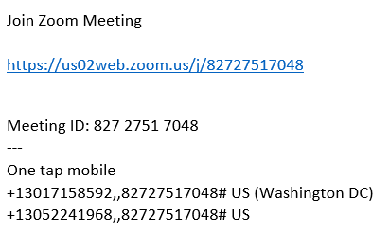

Next Meeting
September 20, 2023
T.B.D.

